**SSNSSA221 Systems Administration I**

**Lab 04 Report**

# Name: Edwin Chen Grade ___/100

**Requirements:**

Make sure to include all screenshots for the report. Each screenshot is worth 11 points. If your screenshots do not have the required information, are illegible, blurry, or unreadable, you will not receive credit. Any attempt to alter the information in the screenshots is dishonesty, and you may fail the course.

**All screenshots must be labeled using the following titles.**

**Figure 1** – Drives Added Verification

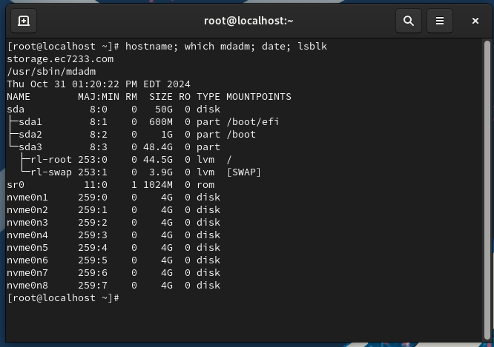

**Figure 2** – Drive Mounted Verification

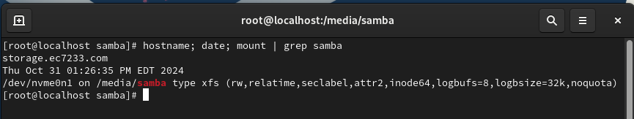

**Figure 3** – RAID 1 Mount Verification

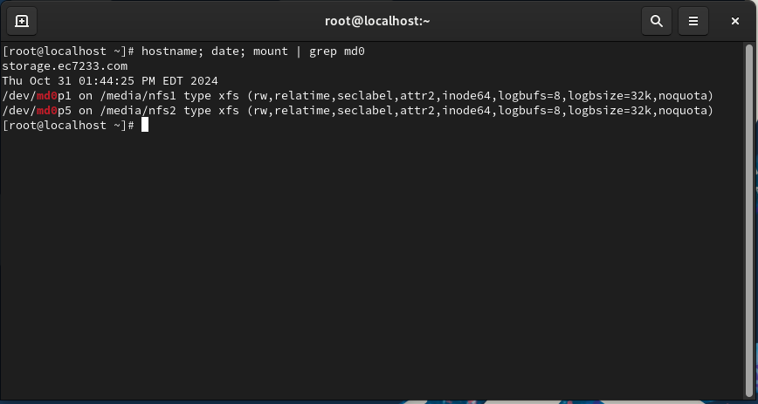

**Figure 4** – RAID 5 Mount Verification

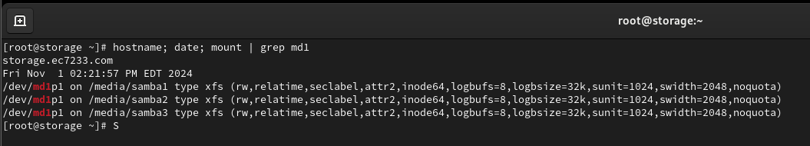

**Figure 5** – Persistent Mount Verification

/dev/nvme0n2 | UUID="9c1201ff-9a18-4407-9e04-e125d5dd5c25" | /media/samba | TYPE="xfs"

/dev/md0p1 | UUID="49a318e4-753a-47e5-b12d-9f09084b2598" | /media/nfs1 | TYPE="xfs"

/dev/md0p5 | UID="7328b04e-bea5-4687-80cd-fe34d06b55bd" | /media/nfs2 | TYPE="xfs"

/dev/md1p1 | UUID="ed9808af-f984-4027-9dec-4f7ba4c3e026" | /media/samba1| TYPE="xfs"

/dev/md2p2 | UUID="cf6a12f6-5be9-4a32-b584-8df9fee0be8c" | /media/samba2 | TYPE="xfs"

/dev/md3p3 | UUID="c3ef1643-57e4-4e94-aaba-2ea3fafc4390" | /media/samba3 | TYPE="xfs"

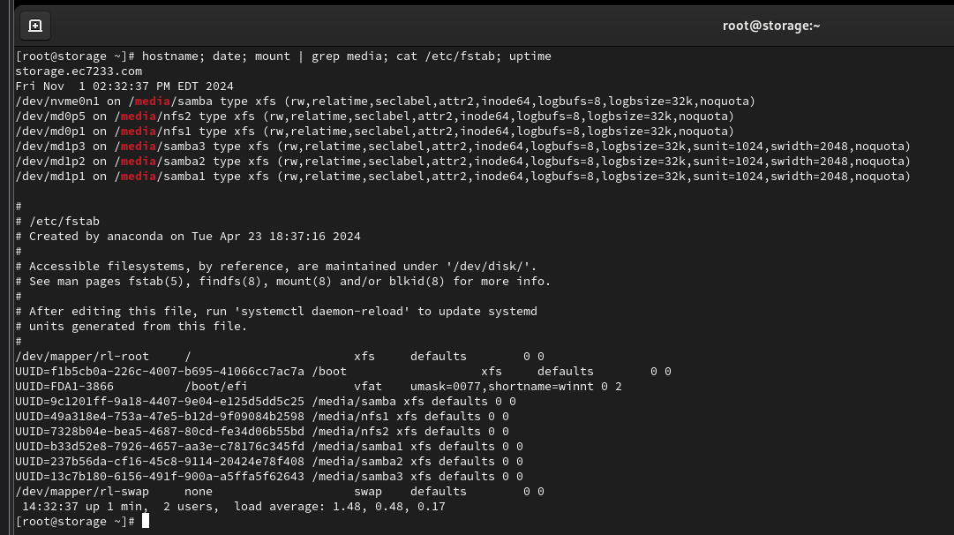

**Figure 6** – RAID Redundancy

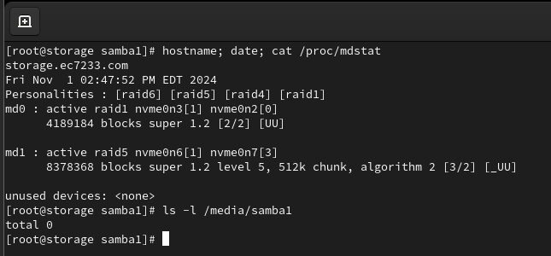

**Figure 7** – Rebuilt RAID Verification

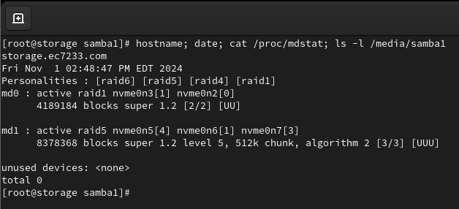

**Figure 8** – LVM Mount Verification

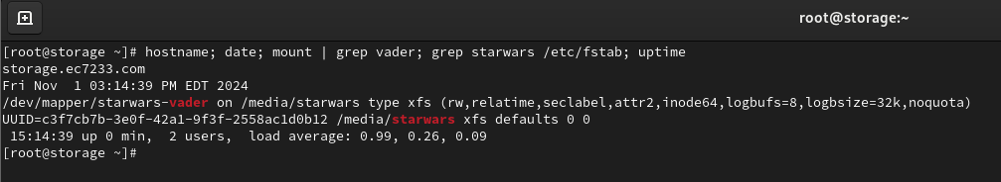

**Figure 9** – LVM Resize Verification

